ECE 323

Jaime Rodriguez

HW#1

***Frequency Mixers***

I choose to do my research assignment on mixers because even though I seen and heard of them I haven’t taken the time to gain a deeper understanding in the subject. I first began by looking into what the textbook had, a mixers is a circuit that capable of taking two input signals which are then multiplied together the resulting output signal are various harmonics, this signal can then be filtered for a desired harmonic. The Gilbert cell; which is a type of mixer using active components (transistors) was first discovered in the early 1960’s by Howard jones, but the circuit s named became attributed to Barrie Gilbert after his redesign brought more optimal performance, and more exact multiplication.

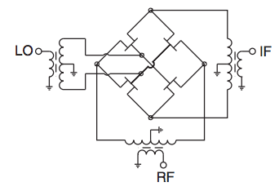 Mixers are generally characterized by two properties, there conversion gain and the noise figure which is a measure of degradation of the signal to noise ratio. There are various types of mixers but most require the need of a non-linear device to perform a switching operation. A very popular topology is the diode ring mixer, which we will eventually go more in depth in this class. In figure 1 we see a combination of the diode ring topology but instead of diodes this circuit uses transistors to switch between the two input signals. There are various forms of mixing signals but one of the interesting and unconventional methods is known as the Rusty Bolt effect. When corrosion builds up on the structure or connector of an antenna, this corroded material can begin acting as a diode, creating a simple unbalanced mixer that can bring unwanted harmonics into the system.

Figure , HJK-251 Mixer Schematic

***References***  
*"Frequency Mixer." Wikipedia. Wikimedia Foundation, 10 Dec. 2014. Web. 07 Apr. 2015.*